Annual Report on Curran Index Activities
January 2016
Gary Simons

This report describes the work conducted and progress made with regard to the Curran Index in 2015 with the support of a grant generously provided by the Research Society for Victorian Periodicals. This report both draws upon and builds upon information previously provided in March 2015 and December 2015 Curran Index updates published under the auspices of Patrick Leary’s Victoria Research Web site and on a conference paper, “Characterizing Contributors to Victorian Periodicals: Querying the Curran Index,” presented on July 10, 2015 at the RSVP annual conference in Ghent.

- Introduction

The Curran Index (CI) is both a research project and an online reference tool dedicated to the identification of the men and women whose essays, stories, and poems appeared anonymously in nineteenth-century British periodicals. The Curran Index continues and extends the work of the Wellesley Index, a multi-decade project. Eileen Curran, one of the Wellesley's editors, continued to examine authorship of contributions to the Victorian press after the Wellesley’s last volume was published in 1989. Her continuing attribution scholarship (as well as the work of other scholars) were first published in print in the Victorian Periodicals Review; later, with the encouragement of Patrick Leary, this material was gathered together online as the Curran Index. Professor Curran continued to publish online Curran Index updates as long as she could; since her death the CI has been continued by the current editor, Gary Simons.
Initially the CI emphasized additions and corrections to the Wellesley Index; in recent years, however, the Curran Index has increasingly encompassed both writings (i.e. verse) and periodicals which were not covered by the Wellesley Index. The Curran Index was supported in 2014 and 2015 by grants from the Research Society for Victorian Periodicals. The proposal submitted to the RSVP for 2015 anticipated trips to examine Eileen Curran’s archives at Colby College and to report on Curran Index activities at the annual RSVP meeting at Ghent: both of these trips have occurred. Additionally, the proposal delineated tasks in three areas: (1) the general expansion and growth of the CI, to include a Wellesley-like analysis of poetry in the New Monthly Magazine, the inclusion of information on the Church Quarterly Review, and other additions; (2) the reformulation of the HTML – list structure of the CI into a Structured Query Language compatible database, with the goal of making this information more searchable and web-accessible, and (3) demonstrations of the generation of useful quantitative information (what I have come to call “quantitative constructs of mass contributorship”) from the Curran Index. In the following progress is reported in each of these three areas.

- Growth and Expansion of the Curran Index

One major omission of the Wellesley Index was the failure to incorporate verse. Victorian miscellanies featured interspersed poetry and prose. Houghton and his associates questioned the lasting value of Victorian periodical poetry and consequently excluded it from consideration. Now, after Linda Hughes’ influential article, "What the Wellesley Index Left Out: Why Poetry Matters to Periodical Studies," Victorian Periodicals Review, 40 (2007), 91-125, periodical verse’s value is indisputable. Ignoring verse renders our understanding of the construction and presentation of miscellanies, the contributors to these periodicals, and the values and interests of the Victorian reading public substantively incomplete.
Eileen Curran recognized this deficiency in 1999 when she published in Victorian Periodicals Review an extended bibliographical study of verse in Bentley’s Miscellany. Others are now also addressing this shortfall, perhaps most notably in Alison Chapman’s Victorian Poetry Network and in the Periodical Poetry Index, co-directed by Natalie Houston, Lindsy Lawrence, and April Patrick. In 2015 the Curran Index made its own contributions:

- Professor Curran’s 1999 study of verse in Bentley’s Miscellany through 1854 has been incorporated into the CI, as has the many revisions and augmentations provided in previous Curran Index updates, and extended set of brand new corrections and additions. Over 950 poems or groups of poems from Bentley’s have been brought into the CI.
- As proposed, verse in the New Monthly Magazine from 1821 to 1854 has been analyzed and bibliographic information has been provided for over 1800 separate poems or groups. Since many of those poems were subsequently reprinted in volumes with named authors, we have been able to attribute 75% of these verses. Some frequent contributors are now well known: Felicia Hemans, Thomas Campbell, Letitia Landon (L.E.L), Thomas Hood, Leigh Hunt, and Bryan Waller Procter (Barry Cornwall). Other frequently encountered names might be more surprising. The humorists James and Horace Smith together contributed almost 200 verses, and their niece Maria Abdy, a prolific poet and story writer who has almost disappeared from literary history, contributed almost 50 works. Cyrus Redding, the active subeditor during the 1820s, contributed over 100 poems. And there is evidence that poems cited by recent biographers of Leigh Hunt and Theodore Hook as being particularly representative of their respective principals were, in fact, written by others.
- Stimulated by an initial listing kindly provided by David Latané, a bibliography of verse in Fraser’s Magazine in the years 1831-1854 enumerating almost 700 poems has been added to the CI. The most frequent known verse contributors to the 1830s FM – William Maginn, James Hogg, John Abraham Heraud, Robert Macnish, Thomas Powell, Bryan Waller Procter – are well represented, as are 1840-1854 contributions by Coventry Patmore, Charles Kingsley, Frederick Tennyson, Arthur Hugh Clough, George Meredith, William Allingham, and others.

All told, the Curran Index now provides extensive coverage of verse in the early Victorian London monthlies.
Major additions have also been made to the CI with regard to prose in monthlies or in quarterly reviews. The identification, acquisition of copies, and analysis of an additional collection of letters by Frederick Marryat has supported the revision and substantial improvement of our earlier listings of the Metropolitan Magazine, a miscellany of the 1830s and 1840s.
Partial listings have been introduced for two important religious periodicals. The Wellesley team initially intended to include the Church Quarterly Review, the voice of high church Anglicanism in the last quarter of the nineteenth century. However, Walter Houghton set the bar for inclusion in the Wellesley Index at an attribution rate of roughly 75%. When it was clear that nothing close to that rate was likely to be realized for the CQR, Josef Altholtz, who was investigating that periodical, instead published a limited set of attributions in “The Church Quarterly Review,” Victorian Periodicals Review, Vol. 17, No. 1/2 (Spring - Summer, 1984), pp. 52-57. Although this information is therefore available to those who carefully seek it, it is an “orphan,” in that it is not associated with a larger collection of periodical bibliographic information. If one is interested in the work of a specific author – in the case of the CQR, say William Gladstone or Charlotte Yonge – it may be important to know at least some of the articles that author contributed to a periodical even if other contributions remain hidden. Accordingly, in March we incorporated Josef Altholtz’s bibliographic analysis of the Church Quarterly Review; in December that listing was substantially enhanced. Additionally, Russell Wyland kindly provided some early listings for the British Critic, which have been incorporated as a forerunner to our planned inclusion of a several-decades-old 1824-1843 listing by Esther Houghton which has never been published.
In 1991 Eileen Curran published a Wellesley-like analysis of the Foreign Review, a publication studded with distinguished contributors like Southey and Carlyle. With the December update her analysis was incorporated into her namesake index. On several occasions the late Eileen Curran also announced her intent to publish an attribution analysis for the Foreign and Colonial Quarterly Review, a mid-1840s periodical distinguished by contributions from Gladstone and other prominent literary and political personalities. Unfortunately, she did not live to bring that project to completion. Using her surviving notes from archives at Colby College as a starting point, a baseline for this periodical has been added to the Curran Index.
The table below summarizes the current (December 2015) article counts per periodical in the Curran Index Database:

Periodical | Prose | Verse
Bentley’s Miscellany | 382 | 954
British Critic | 25
Calcutta Review | 133
Church Quarterly Review | 214
Foreign Review | 131
Foreign and Colonial Quarterly Review | 184
Fraser’s Magazine | 106 | 671
Metropolitan Magazine | 2120 | 204
New Monthly Magazine | 78 | 1810
Other Periodicals | 509 | 14
Totals | 3882 | 3653

A major effort has been made to ascertain and provide extended biographical information regarding the contributors of articles listed in the Curran Index Database. As of this update, 988 contributors, including 462 who were not listed in the Wellesley Index, have been identified. As a further point of reference, approximately half of the 988 contributors are not listed in the Oxford Dictionary of National Biography.

- The Curran Index Database

At its inception the Curran Index was structured as a flat HTML file; starting in 2013 major additions were introduced as supporting pdf files. As proposed, we have migrated this combined base of information to an SQL database. At first, for convenience this database was conceived in MS Access; now the database has been converted to MYSQL. In its current formulation the database has four central tables: periodicals, articles, contributors, and essays (with dozens of associated queries and, in Access, associated reports). The periodical table has a numerical ID field, a name field, an abbreviation field, and two memo-type (unlimited size fields) that are used for introductions, references to related works, and information regarding the periodical that did not fit neatly into other areas. The essay table has, as its name implies, essays that either Eileen Curran or I wrote introducing various Curran Index updates and covering various topics associated with attribution scholarship.
The contributor table has, in addition to the standard ID, name, gender, and life date fields, an identifier field (to distinguish different contributors who have the same name); fields for nationality and education; three yes/no fields to indicate whether the contributor is listed in the Wellesley Index, included in Boase's Modern English Biography, or listed in ODNB; and a memo field to cover major life experiences, other literary works, etc. The article table has, at present, 18 fields, including ID, linkage fields to the appropriate periodical and appropriate contributor(s), volume and issue numbers, nominal publication date, start and end pages, article types and codes, attribution confidence levels, etc.
None of this is, of course, set in stone – further changes which will improve the structure of the database are anticipated. As of December 2015, there are 38 periodicals listed in the periodical table, 8 essays in the essay table, 988 contributors, and 7,535 indexed articles.
The major remaining task is to create a web interface for this database. I have exchanged several emails with Jim Mussell and, at his request, am in the process of preparing a costing specification for this interface (which will presumably be implemented in PHP). The Curran Index web interface should support several kinds of user interaction:
Browsing: One of the pleasures of the old red Wellesley books was the ability to browse, to look for example through the chronologically organized table of contents listing of a periodical, or to look through an alphabetically-organized list of contributors with all associated articles listed for each contributor. This capability needs to be available to web users of the CI. But users should also be able to browse in different ways -- a user should, for example, be able to browse through a list of all articles (regardless of periodical) published, say, in April 1843.
Searching: Of course standard searches, such as all the articles in the CI associated with a given issue of a periodical, or all the articles with a given word in the title, or all the articles in the CI from a certain contributor, need to be supported. But we can do much more as a research tool. As examples, a user should be able to generate a list of all the articles written by American authors; or a list of all the articles from contributors who attended Trinity College, Dublin; or a list of all the articles written by Scottish authors born between 1790 and 1805; or all the translations of Schiller. All this information is implicit in the CI database.
Querying: At the recent Ghent conference (see Section IV below) I discussed various "quantitative constructs of mass contributorship." If one can attribute most articles in a periodical, one can also associate issues, volumes, or entire runs of periodicals with aspects of their contributors. One could, for example, develop age profiles or gender profiles of contributors, and ascertain how they change over time, with editor changes, or across different periodicals. One can similarly consider the "celebrity" of the contributors to periodicals, or their nationalities, or their educations. One could compute stability indices (at what rate does the contributor base of a given periodical change over time) or concentration indices (what fraction of articles are contributed by how many contributors). Much of this information is implicit in the Wellesley index but users have no way to retrieve it. A Curran Index web interface which supports querying can open up new research possibilities.

- Quantitative Measures of Contributorship

In July at Ghent I proposed constructs which could be drawn from the Curran Index database which might provide statistical insights into the contributor portion of the contributor-editor-reader triangle. Several of the charts from that presentation and their respective talking points are presented in the following:
Using the information available at that time (July 2015), one could create the following summary profile for contributors to nineteenth century British periodicals:
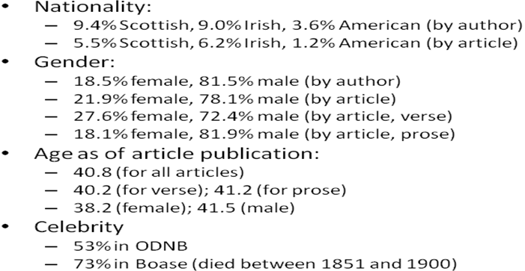
To the best of my knowledge, this is the first time a profile of this type has been created.
Statistical averages are only meaningful if they are based on large numbers of data points. Thus, looking at the next chart of the average ages of periodical contributors, the last column on the chart on the left, suggesting that the average age of contributors to periodicals published in the 1850s is a little over 42, is only speculative. 69 data points just aren’t enough.
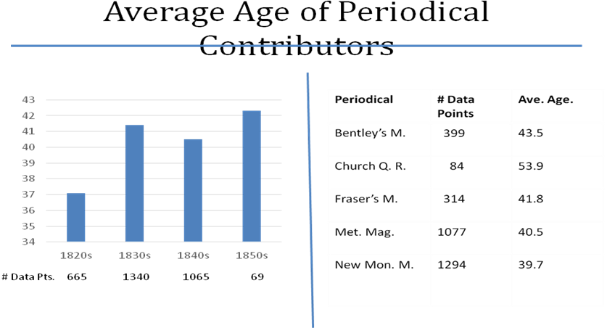
However, as shown on the chart the July 2015 CI had a great deal of data for the 1820s, 1830s, and 1840s. And while the average age of contributors in the 1830s and 1840s are very close, contributors in the 1820s were substantially younger. Four years is a very significant difference – were periodical contributors actually younger in the 1820s, and if so, why? At this point I can only speculate. Much of our 1820s data comes from verse– was Byronism influencing potential young poets and drawing them into contributing to periodicals? Or was the effect more general – was periodical authorship, in fact, more of a young person’s game in the 1820s than later in the century? More data is needed to answer this question.
Contributor ages do vary (a little) between periodicals. Bentley’s tends to skew a little older than Fraser’s, the Metropolitan Magazine, and the New Monthly Magazine – might that reflect a conservatism of taste? Once again, much of our Bentley’s data comes from the late 1840s or early 1850s – was then editor William Harrison Ainsworth relying more on his contemporaries? The contributors to the Church Quarterly Review – whose contributors were often well-established clerics – are older, but here again we see the risks of drawing conclusions from limited data. As of June 1, based on 84 articles, the average age of a CQR contributor was almost 54; as of today, based on 149 articles, that average age has slipped just below 50. Additionally, the CQR began publication in 1875 – and perhaps writing became a profession for older writers as the century progressed.
“Celebrity” ratings might be constructed by considering what fraction of the articles in a given periodical was written by authors who were subsequently included in the Oxford Dictionary of National Biography, or in Frederick Boase’s Modern English Biography. This is an uncertain measure, in that celebrity “now” is not necessarily reflective of celebrity “then”; nevertheless, the numbers are interesting. I have compared the number of articles with known authors with the number of articles whose authors are 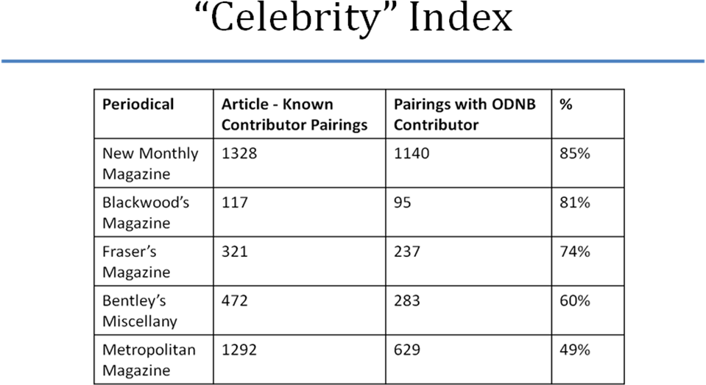
included in ONDB. The Blackwood’s Magazine number is based on very limited data and is thus questionable, but there should be enough data to make the other computations meaningful. Of the listed periodicals the Metropolitan Magazine would certainly be considered the least prestigious, and it does, indeed, have the lowest celebrity rating. The New Monthly Magazine, Blackwood’s Magazine, and Fraser’s Magazine are fairly closely bunched. I am a bit surprised at the rating of Bentley’s Miscellany- but the data for Bentley’s may not be fully representative as it heavily reflects the late 1840s and early 1850s.
Of course, periodicals evolve over time. Thus, one might want to look at constructs like author age, gender ratio, and celebrity and see how they change as periodicals change. And that is just what has been done on the following chart. Between 1828 and 1848 the New Monthly Magazine had a number of different editors, ranging from the Thomas Campbell / Cyrus Redding combination in the late 1820s up to Ainsworth’s takeover in 1845. On the graph the green line shows the percentage of verse in the NMM written by writers in ONDB, and the blue the percentage of verse written by women.
Up until 1836 – through the tenures of Campbell, Hall, Bulwer, and then again Hall – almost all of the poetry in the NMM was written by ODNB-listed poets. Presumably that marks both the prominence of verse in that era as well as the NMM’s success in recruiting more prominent poets. But early in the regime of Theodore Hook that fell apart. Thomas Hood reestablished the celebrity of NMM poetry, but Ainsworth was apparently unable or unwilling to sustain that performance.
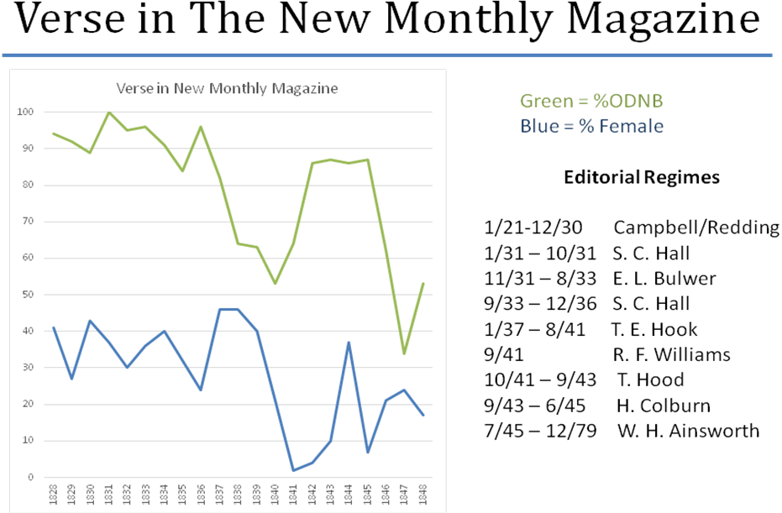
Moving to the blue line, between 1828 and 1837 about 1/3 of the poetry in NMM was written by women; in the late 1830s again under Hook, that rose to almost 50%, and then plummeted. After Hook subsequent editors apparently did not succeed in recruiting women poets except for a spike in 1837 (primarily based on lots of L.E.L. and Caroline Sheridan Norton).

- Conclusion

I once again thank the RSVP for the generous support that enabled the above work to be conducted. I believe it is fair to conclude that considerable progress has been made in 2015 with regard to extending the number of entries in the Curran Index, with reformulating the index as a Structured Query Language compatible database, and with demonstrating that potentially interesting constructs of mass contributorship can be drawn from the Curran Index Database.
Goals for 2015 include further major extensions of the database, the development of a web database interface and the placement of this interface and database on the RSVP site, and the computation and testing of other statistical measures of contributorship.

